**CHAPTER 3**

**Implementation Details**

* 1. **Schematic Diagram and its description**

`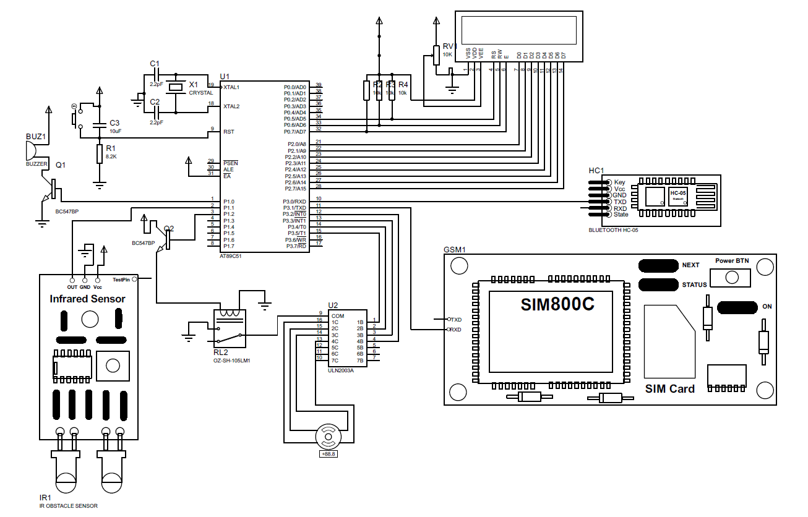

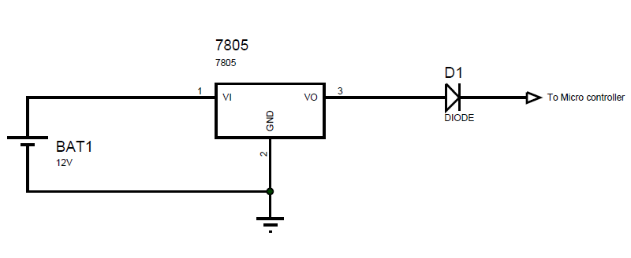

**Figure x Schematic Diagram**

* + 1. **Schematic Description**

5V DC adapter is used for the Power supply. This power supply supplies power to the controller, Stepper motor, IR sensor module, GSM module as well as the Bluetooth module.

Also as shown in schematic, there is a 12V battery connected in parallel with the adapter. The battery voltage is regulated using the LM7805 IC to give a constant output voltage of 5V as all the components in the circuit operate on 5V. There is a diode connected in series with the battery. This diode is used to prevent the flow of the reverse current in the battery. Also, this diode prevents the flow of current from the battery when the main power supply is ON as the it is reverse biased by the main power supply. When the main power supply is Cut-Off the reverse voltage across the diode is not there and then the power is supplied from the battery.

We are using the GSM module only for making the missed calls so we will be sending commands to the GSM module and are not interested to receive any data from it. So we have connected the Rx pin of GSM module to Tx pin of the controller and the Tx pin of GSM module is left open.

Similarly, we are using the HC-05 Bluetooth module to receive data from the user and we will not be sending any data via the Bluetooth module. So the Tx pin of HC-05 is connected to the controller and the Rx pin is left open.

* 1. **Software Description**
     1. **Proteus**

Proteus (PROcessor for TExt Easy to USe) is a fully functional, procedural programming language created in 1998 by Simone Zanella.

Proteus incorporates many functions derived from several other languages: C, BASIC,Assembly, Clipper/dBase; it is especially versatile in dealing with strings, having hundreds of dedicated functions; this makes it one of the richest languages for text manipulation.

Proteus owes its name to a Greek god of the sea (Proteus), who took care of Neptune's crowd and gave responses; he was renowned for being able to transform himself, assuming different shapes.

Transforming data from one form to another is the main use of this language.

* + 1. **Keil µVison-3**

To develop the code and for compiling our project C program we have used Keil µVison3 IDE.

**Keil µVision** is a free software which solves many of the pain points for an embedded program developer. This software is an integrated development environment (IDE), which integrated a text editor to write programs, a compiler and it will convert your source code to hex files too.

* 1. **Flow Chart**

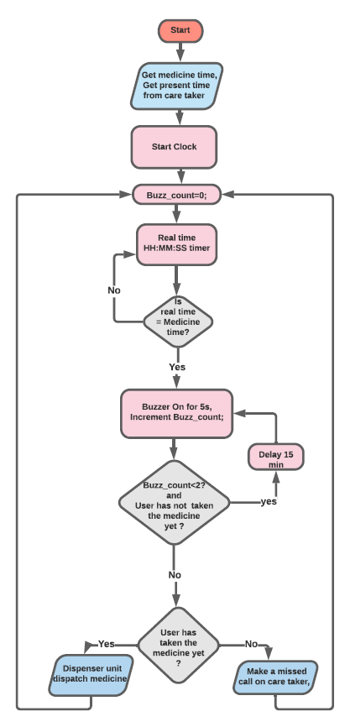

**Figure x Flow Chart of Program**

* 1. **Flow Chart Description**

Take the medicine schedule and the present time from the caretaker. After taking the present time start the clock inside the microcontroller.

Initialize the variable buzz_count to 0 value. This variable indicates how many times the buzzer buzzed. The clock generated inside the microcontroller is displayed on the LCD connected to the microcontroller.

The controller is continuously checking if it is the time to take the medicine. If it is time to take the medicine has come then the buzzer makes a sound for 5 seconds to alert the patient to take the medicine. Also, then the buzz_count value is incremented as the buzzer has buzzed once.

If the patient comes to take the medicine, then the machine dispenses the medicine and then goes back to check the medicine time for next medication time.

But if. even after alerting the patient to take the medicine if he/she fails to take it, the device tries to alert the patient again by turning the buzzer on for 5 seconds. Even after alerting the patient twice if he/she fails to take the medicine then the device will make a missed call to the caretaker indicating him/her that the patient has failed to take the medicine even after alerting them twice.